WEEK – 1

Implementing the stratergy Pattern

Nipuna Amanapu

[namanapu@gitam.in](mailto:namanapu@gitam.in)

superset id : 6432842

**Exercise 8: Implementing the Strategy Pattern**

**Scenario:**

You are developing a payment system where different payment methods (e.g., Credit Card, PayPal) can be selected at runtime. Use the Strategy Pattern to achieve this.

**Steps:**

1. **Create a New Java Project:**
   * Create a new Java project named **StrategyPatternExample**.
2. **Define Strategy Interface:**
   * Create an interface PaymentStrategy with a method **pay()**.
3. **Implement Concrete Strategies:**
   * Create classes **CreditCardPayment**, **PayPalPayment** that implement **PaymentStrategy**.
4. **Implement Context Class:**
   * Create a class **PaymentContext** that holds a reference to **PaymentStrategy** and a method to execute the strategy.
   * method to execute the strategy.
5. **Test the Strategy Implementation:**
   * Create a test class to demonstrate selecting and using different payment strategies.

Solution:

1. PaymentStrategy.java

public interface PaymentStrategy {

    void pay(double amount);

}

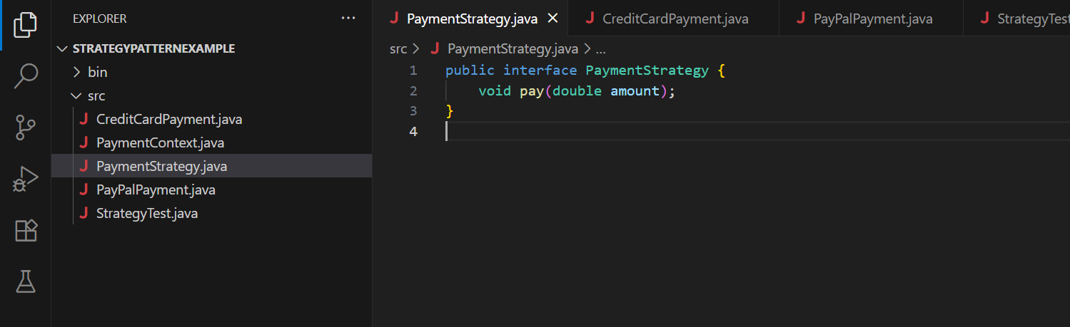

1. CreditCardPayment.java

public class CreditCardPayment implements PaymentStrategy {

private String cardNumber;

public CreditCardPayment(String cardNumber) {

this.cardNumber = cardNumber;

}

@Override

public void pay(double amount) {

System.out.println("Paid " + amount + " using Credit Card: " + cardNumber);

}

}

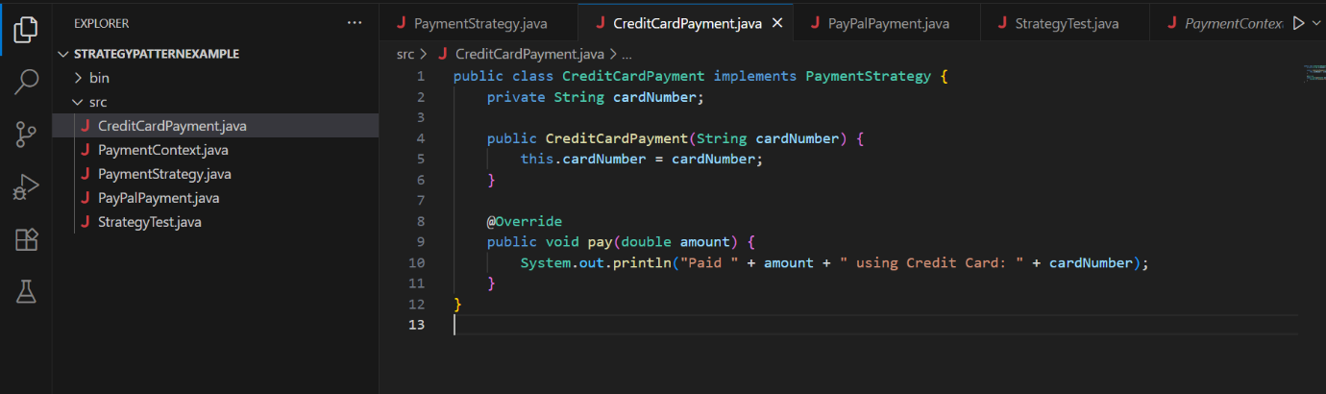

1. PayPalPayment.java

public class PayPalPayment implements PaymentStrategy {

private String email;

public PayPalPayment(String email) {

this.email = email;

}

@Override

public void pay(double amount) {

System.out.println("Paid " + amount + " using PayPal account: " + email);

}

}

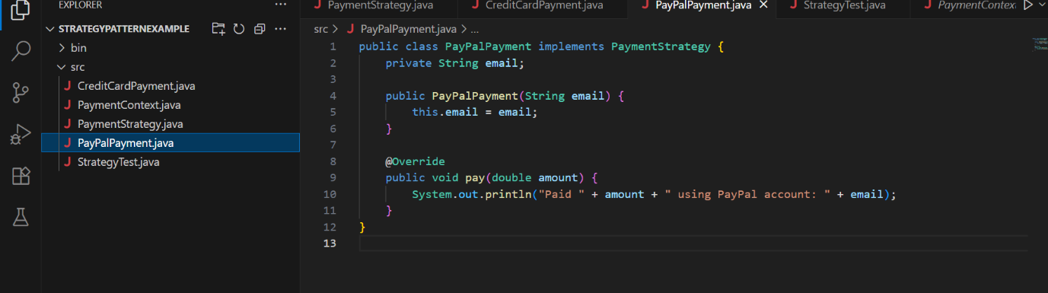

1. PaymentContext.java

public class PaymentContext {

private PaymentStrategy strategy;

public void setPaymentStrategy(PaymentStrategy strategy) {

this.strategy = strategy;

}

public void payAmount(double amount) {

if (strategy == null) {

System.out.println("No payment strategy selected.");

} else {

strategy.pay(amount);

}

}

}

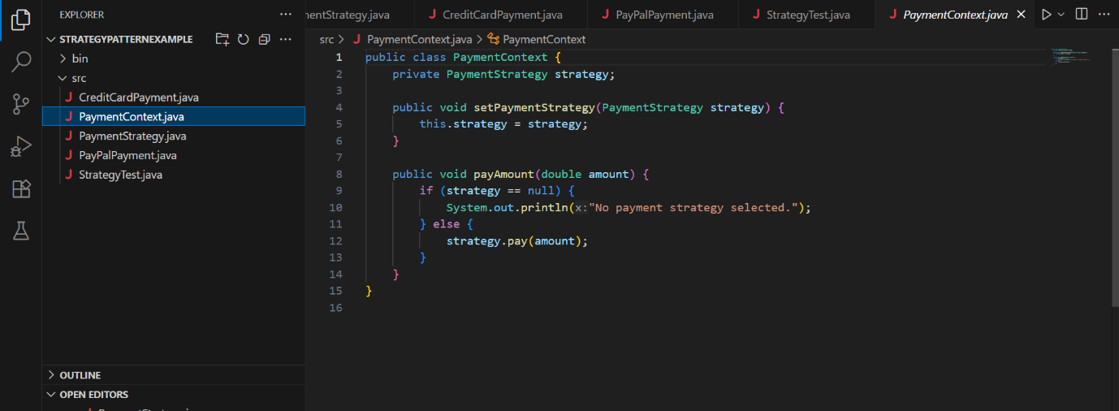

1. StrategyTest.java

public class StrategyTest {

public static void main(String[] args) {

PaymentContext context = new PaymentContext();

context.setPaymentStrategy(new CreditCardPayment("1234-5678-9876-5432"));

context.payAmount(250.0);

context.setPaymentStrategy(new PayPalPayment("user@example.com"));

context.payAmount(100.0);

}

}

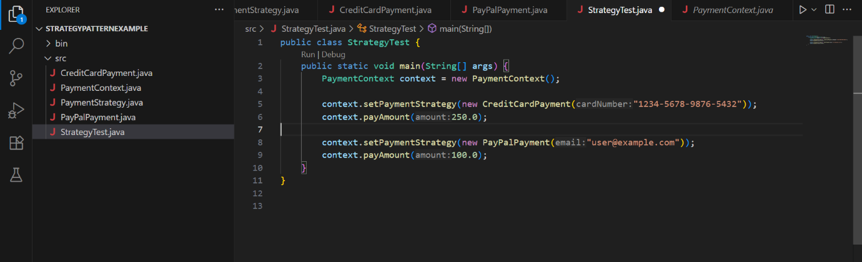

Output:

